**Project Design Phase-II**

**Technology Stack (Architecture & Stack)**

|  |  |
| --- | --- |
| Date | 28 June 2025 |
| Team ID | LTVIP2025TMID59308 |
| Project Name | **BookNest: Where Stories Nestle** |
| Maximum Marks | 4 Marks |

**Technical Architecture:**

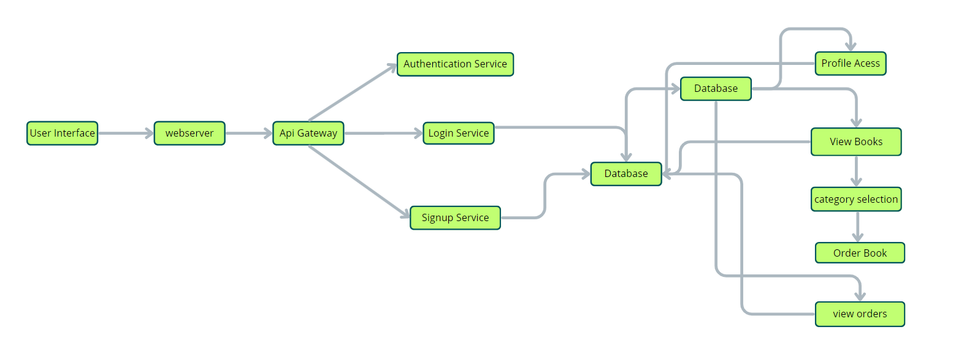

**Table-1 : Components & Technologies:**

| **S.No** | **Component** | **Description** | **Technology** |
| --- | --- | --- | --- |
| **1** | **User Interface** | **Web UI for users, admin, and sellers** | **HTML, CSS, JavaScript, React.js** |
| **2** | **Application Logic-1** | **Core logic for login, book search, order placing** | **Node.js, Express.js** |
| **3** | **Application Logic-2** | **Book CRUD, image upload, authentication** | **Node.js, JWT, Multer, Cloudinary** |
| **4** | **Application Logic-3** | **Admin dashboard (analytics, role access)** | **Node.js, Express.js, Recharts** |
| **5** | **Database** | **NoSQL database for storing app data** | **MongoDB** |
| **6** | **Cloud Database** | **Cloud-hosted MongoDB instance** | **MongoDB Atlas** |
| **7** | **File Storage** | **Book cover image storage** | **Cloudinary** |
| **8** | **External API-1** | **Fetching book covers** | **Open Library Covers API** |
| **9** | **External API-2** | **Payment gateway (optional/future)** | **Razorpay API** |
| **10** | **Machine Learning Model** | **Not applicable** | **N/A** |
| **11** | **Infrastructure** | **Frontend & backend hosting, cloud DB** | **Vercel, Render, MongoDB Atlas** |

**Table-2: Application Characteristics:**

| **S.No** | **Characteristics** | **Description** | **Technology / Approach** |
| --- | --- | --- | --- |
| **1** | **Open-Source Frameworks** | **Backend and frontend use open-source libraries** | **Express.js, React.js, MongoDB, Tailwind** |
| **2** | **Security Implementations** | **JWT for authentication, bcrypt for password hashing** | **JWT, bcrypt, HTTPS, CORS** |
| **3** | **Scalable Architecture** | **Separation of concerns (frontend, backend, database)** | **3-tier architecture** |
| **4** | **Availability** | **Cloud deployment ensures 24/7 access** | **Vercel, Render, MongoDB Atlas** |
| **5** | **Performance** | **Efficient API calls, use of caching for DB queries (optional)** | **REST APIs, Indexing in MongoDB** |